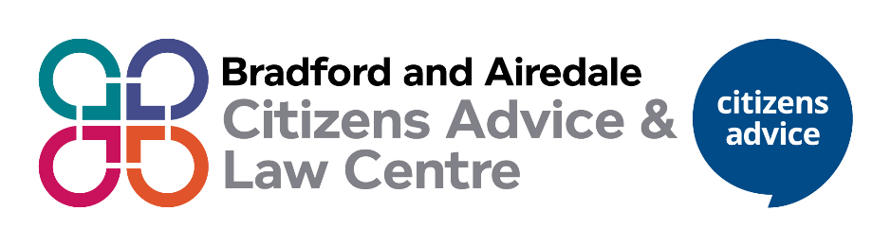
Research and Campaigns Volunteer


What will you do?
- complete an introduction to Citizens Advice
- create leaflets and posters to promote the service, or use existing materials
- use social media, for example, Facebook and LinkedIn to raise the profile of the local Citizens Advice
- help to share what local Citizens Advice does with your local press or radio station
- write information for the local Citizens Advice website or newsletter
- talk to clients or volunteers about their experiences
- help arrange a talk or event to promote the local Citizens Advice to others
- Raise awareness with staff and volunteers of current social policy issues.

- Check evidence forms regarding clients’ issues and problems and analyse the results in terms of main trends, identifying potential campaigning issues

- help to organise a campaign with the aim of getting the organisation (person or elected body such as MP, AM or local councillor) that is causing the problem, to change the way they do things. This could mean meeting with the organisation, person or elected body, writing to them or holding an event
- help national Citizens Advice carry out research about how certain issues affect clients in your local area. This might involve doing a survey with clients to find out how a change in a benefit is affecting them
- take an interest and gain understanding about what staff and volunteers are doing around researching client issues and campaigning for change, and how this fits in with national Citizens Advice
- keep up to date with local and national research and campaigns issues by signing up to newsletters
- Help provide information and evidence for a full report on research and campaigns
- get in touch with those in your network to promote the Research and Campaigns activity that the local Citizens Advice is doing

What’s in it for you?
- use your experience make a real difference to people’s lives
- learn about a range of areas such as benefits, immigration, debt and housing, and how problems in these areas can affect clients
- increase your employability
- work with a range of different people, independently and in a team.
- build on valuable skills such as communication, research, campaigns, how to engage with a range of audiences and working with clients

- build on valuable skills such as communication, listening, marketing and advertising
- have a positive impact in your community and on broader society
And we’ll reimburse your incurred expenses too.

What do you need to have?
You don’t need any specific qualifications or skills but you’ll need to have an interest in research and campaigns work
- be friendly, patient and approachable
- be non-judgmental and respect views, values and cultures that are different to your own
- have good listening skills
- have excellent verbal and written communication skills
- have excellent IT skills
- have an understanding of social media and how to utilise it
- be able to understand information and explain it to others
- be willing to learn about and follow the Citizens Advice aims, principles and policies, including confidentiality and data protection
- be willing to undertake training in your role


How much time do you need to give?

You’ll likely need to give 6 hours a week and you may need to attend research and campaigns meetings, or meet with volunteers and staff occasionally within the at our local Citizens Advice offices across the district. We can be flexible about the time spent, days and hours between Monday to Friday, so come and talk to us.

Valuing inclusion

Our volunteers come from a range of backgrounds.
If you are interested in becoming our research and campaigns volunteer and would like to discuss flexibility around location, time, ‘what you will do’ and how we can support you please contact us.

Contact details

[insert as needed]

