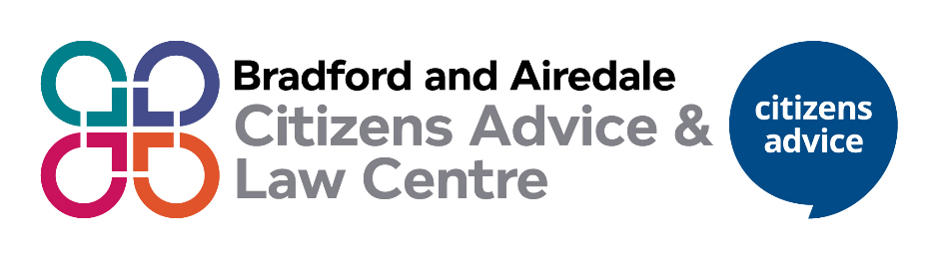
Information and Data Volunteer


What will you do?
- complete an introduction to Citizens Advice
- To analyse a range of data including demographic data, client data, financial data and client feedback
- Produce a range of reports as required both for the organisation itself and our funders
- Use data to identify any gaps in our service provision to help us develop future projects and services.
- Contribute to any funding bids, funder reports or awareness campaigns which require data to support the work being produced.
- write information for the local Citizens Advice website or newsletter
- Raise awareness with staff and volunteers about the importance of data.

- keep up to date with local and national data research by signing up to newsletters
- Help provide information and evidence to contribute to reports

What’s in it for you?
- learn about a range of areas such as benefits, immigration, debt and housing, and how problems in these areas can affect clients
- build on valuable skills such as leadership and strategic direction
- increase your employability
- work with a range of different people, independently and in a team.
- build on valuable skills such as communication, data analysis, numeracy skills and use of packages such as Excel, Microsoft Forms and PowerBI
- have a positive impact in your community and on broader society
And we’ll reimburse your incurred expenses too.

What do you need to have?
You don’t need any specific qualifications or skills but you’ll need to have an interest in research and campaigns work
- be friendly, patient and approachable
- be non-judgmental and respect views, values and cultures that are different to your own
- have good listening skills
- have excellent verbal and written communication skills
- have excellent IT skills
- have an understanding of social media and how to utilise it
- be able to understand information and explain it to others
- be willing to learn about and follow the Citizens Advice aims, principles and policies, including confidentiality and data protection
- be willing to undertake training in your role


How much time do you need to give?

You’ll likely need to give 6 hours a week and you may need to meet with volunteers and staff occasionally at our local Citizens Advice offices across the district. We can be flexible about the time spent, days and hours between Monday to Friday, so come and talk to us.

Valuing inclusion

Our volunteers come from a range of backgrounds.
If you are interested in becoming our research and campaigns volunteer and would like to discuss flexibility around location, time, ‘what you will do’ and how we can support you please contact us.

Contact details

[insert as needed]

