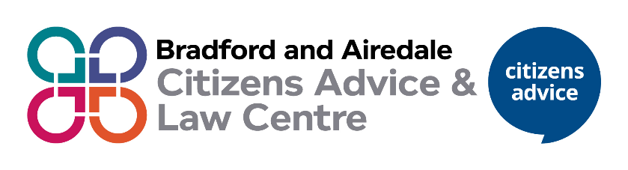
Role | Client and Community Assessment Officer  I full time role and 2 part time roles at 22.2 hours
Location | This is a hybrid role between in-office at Keighley and Bradford office with the option for 2 days home working after probation
Salary | £24,500 - £25,500 FTE  Depending on experience  Part time pro rata (£14,700)
Hours | 37 hours per week

Bradford and Airedale Citizens Advice and Law Centre is a leading provider of legal advice and information, supporting thousands of clients every year. We are a busy, client focused and dynamic service with a track record of delivering high quality advice.
This role is a great opportunity to help have a positive impact on clients accessing our service. To help support residents find a way forward.
We are looking to appoint a dedicated, flexible and client focused individual who enjoys working with a wide range of people.
As a Client and Community Assessment Officer, you will be passionate about supporting people, with the ability to work with culturally diverse communities and groups. You will be the first point of contact for our service. The post holder will be expected to be able to quickly identify a clients advice need, their ability to self-help and what the next steps are for the client.
Broadly, your primary responsibilities will cover the following areas:
- Answering inbound calls through our adviceline
- Dealing with clients via our digital channels
- Attending to clients at face-to-face drop-in sessions
- Assess urgent matters which need specialist input and arrange internal referrals to colleagues within the organisation for further advice/specialist advice & casework in money advice, welfare benefits, immigration and housing.
- Booking advice appointment and completing internal referrals
- Provide signposting and self-help to empower clients to progress their enquiry
- Support the development and delivery of our access channels
You will have excellent communication and interpersonal skills. You will self-motivated, with strong research, telephone and IT skills and have the ability to contribute positively whilst having a flexible approach to service delivery.
At Bradford and Airedale Citizens Advice and Law Centre we value diversity, promote equality and challenge discrimination. We encourage and welcome applications from people of all backgrounds.
To apply on line submit a covering letter with CV by following link https://bradfordcitizensadvicebureau.peoplehr.net/Pages/JobBoard/Opening.aspx?v=4d8c1907-91ca-481d-9372-aa5de91535f7
Closing Date:- 4.00 pm Monday 1st June 2026
Interviews: Wednesday 10th & Friday 12th June 2026

